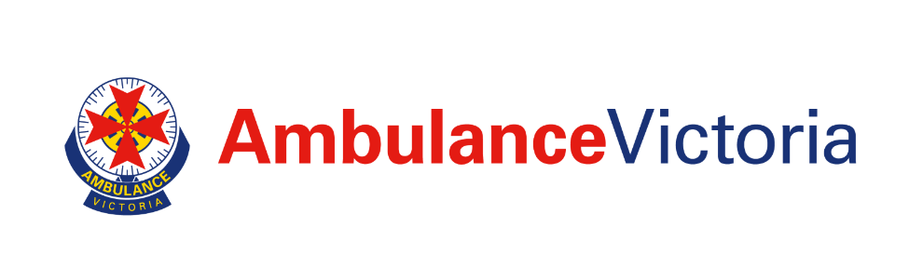
Reflect Reconciliation Action Plan

May 2023 – December 2024

Acknowledgement of Country
Ambulance Victoria acknowledges the Traditional Owners of the lands in Victoria. We pay our respects to Aboriginal and Torres Strait Islander cultures and to Elders past and present and recognise Aboriginal self-determination is a human right. We commit to working with our Aboriginal communities to improve our care and services in the spirit of partnership.
Message from the Ambulance Victoria Chief Executive
Ambulance Victoria has been on a journey towards reconciliation since 2018. This is a journey of truth-telling and acknowledgement, to foster unity, respect and develop meaningful relationships with Aboriginal and Torres Strait Islander peoples.

As the state’s provider of pre-hospital emergency care and ambulance services, we are witness to the healthcare-related disadvantage Aboriginal and Torres Strait Islander peoples experience. We know Aboriginal and Torres Strait Islander peoples are more likely to experience poor health outcomes, as a result of health, human rights and social justice inequalities. Factors contributing to this include unequal access to culturally safe health care and health education and higher hospital admission rates compared to non-Indigenous Australians. This is further compounded by the social and systemic impacts of racism which influence employment and education experiences of Aboriginal and Torres Strait Islander people.

We must act now.

This Reconciliation Action Plan is our commitment to enact change and our opportunity to make a difference and improve health outcomes for Aboriginal and Torres Strait Islander Victorians. It is the product of hard work undertaken by many to prepare the organisation so that we can begin addressing this injustice and move toward reconciliation.

The actions in this plan support our organisation and our people to build strong, sustainable and meaningful relationships with Aboriginal and Torres Strait Islander people.

We will increase awareness and appreciation of culture and create better connections with Aboriginal and Torres Strait Islander communities and organisations across Victoria. We will do this with the support, knowledge, expertise and guidance from Aboriginal and Torres Strait Islander people from inside and outside the organisation.

On behalf of Ambulance Victoria, I thank the community members and workforce who have contributed to the development of the Reconciliation Action Plan for your insight, hard work and dedication.

I am committed to, and passionate about, working with Aboriginal and Torres Strait Islander people to make our organisation, and the health services we provide to the community, culturally safe. I will provide the leadership that will enable us to continue to listen, learn and bring this to life.

Working together with Aboriginal and Torres Strait Islander peoples, Ambulance Victoria will provide respectful, responsive, and culturally safe and inclusive services.

Message from the Reconciliation Australia CEO
Reconciliation Australia welcomes Ambulance Victoria to the Reconciliation Action Plan (RAP) program with the formal endorsement of its inaugural Reflect RAP.

Ambulance Victoria joins a network of more than 2,200 corporate, government, and not-for-profit organisations that have made a formal commitment to reconciliation through the RAP program.

Since 2006, RAPs have provided a framework for organisations to leverage their structures and diverse spheres of influence to support the national reconciliation movement. The program’s potential for impact is greater than ever, with close to 3 million people now working or studying in an organisation with a RAP.

The four RAP types — Reflect, Innovate, Stretch and Elevate — allow RAP partners to continuously develop and strengthen reconciliation commitments in new ways. This Reflect RAP will lay the foundations, priming the workplace for future RAPs and reconciliation initiatives.

The RAP program’s strength is its framework of relationships, respect, and opportunities, allowing an organisation to strategically set its reconciliation commitments in line with its own business objectives, for the most effective outcomes.
These outcomes contribute towards the five dimensions of reconciliation: race relations; equality and equity; institutional integrity; unity; and historical acceptance.
It is critical to not only uphold all five dimensions of reconciliation, but also increase awareness of Aboriginal and Torres Strait Islander cultures, histories, knowledge, and leadership across all sectors of Australian society.

This Reflect RAP enables Ambulance Victoria to deepen its understanding of its sphere of influence and the unique contribution it can make to lead progress across the five dimensions. Getting these first steps right will ensure the sustainability of future RAPs and reconciliation initiatives, and provide meaningful impact toward Australia’s reconciliation journey.

Congratulations Ambulance Victoria, welcome to the RAP program, and I look forward to following your reconciliation journey in the years to come.

Karen Mundine
Chief Executive Officer
Reconciliation Australia

Table of Contents
Acknowledgement of Country 1
Message from the Ambulance Victoria CEO 1
Message from the Reconciliation Australia CEO 2
Our vision for reconciliation 4
Statement of Commitment to Reconciliation 4
Our organisation 5
Our Aboriginal and Torres Strait Islander artwork 6
Our Reconciliation Action Plan 8
Our journey to the Reconciliation Action Plan 9
Our Reconciliation Working Group 9
Our partnerships and current activities 10
Our actions 11

Reconciliation Action Plans (RAPs) have enabled organisations to sustainably and strategically take meaningful action to advance reconciliation.
The first step of AV’s reconciliation journey is the development of our ‘Reflect’ RAP. The ‘Reflect’ RAP is our commitment to scoping and developing relationships with Aboriginal and Torres Strait Islander stakeholders, deciding on our vision for reconciliation and exploring our sphere of influence. We recognise that reconciliation is an ongoing journey and look forward to implementing our ‘Reflect’ RAP, which will enable us to progress in our reconciliation journey to an ‘Innovate’ RAP.

Our Statement of Commitment to Reconciliation
At Ambulance Victoria we recognise the diverse and unique cultures and histories of Aboriginal and Torres Strait Islander peoples and value the knowledge of countless generations of Custodians. We commit to working together to build a fair and just future. We will come together with Aboriginal and Torres Strait Islander communities to identify, understand, and develop opportunities to create and sustain a culturally aware organisation.

We will celebrate Aboriginal and Torres Strait Islander cultures and communities to ensure that we prioritise and show respect and dignity to the people we live and work with.
Our goal is fair and impartial care and service of Aboriginal and Torres Strait Islander peoples. We will achieve this by acknowledging that the attitudes we hold can positively or negatively impact health outcomes. We will create a positive shift in these attitudes.

We will collaborate with Aboriginal and Torres Strait Islander communities to ensure safe and supportive environments for individuals and families which promote strength and resilience.

We will work with Aboriginal and Torres Strait Islander communities and organisations to understand our shared priorities and integrate sustainable services which contribute to improving outcomes of physical, emotional, and social health and wellbeing.

This is the beginning of our shared journey. We will listen and learn from each other to create a healthy and vibrant future together.

Our vision for reconciliation
Ambulance Victoria (AV) believes that reconciliation with Aboriginal and Torres Strait Islander communities comes from building strong relationships centred around respect, communication, and understanding.
AV will build meaningful connections through action – consistency, reliability, active listening, and hearing. We will engage and educate our people and the wider Victorian community about the cultures, beliefs, and unique care needs and health outcomes of Aboriginal and Torres Strait Islander peoples.
We will provide all patients with a caring, safe, effective, and connected experience, respectful of ethnicity, culture, spiritual values and beliefs, and individuality. The actions and deliverables in our RAP will strengthen our understanding and connection with Aboriginal and Torres Strait Islander communities and support the delivery of patient-centred Best Care.

Our organisation
AV is committed to improving the community's health by providing high-quality pre-hospital care and medical transport to over 6.5 million people within Victoria. AV delivers a 24/7 state-wide emergency medical response, to Victoria and cross-border regions. The organisation covers an area of more than 227,000 square kilometres and has around 260 different locations across metropolitan, regional, and rural areas.

AV works at the intersection of health and emergency management. The organisation provides emergency pre-hospital treatment, ambulance and air ambulance transport for people facing medical emergencies and who have called Triple Zero (000). It also provides important non-emergency patient transport and critical care adult retrieval services between hospitals.

AV’s Strategic Plan outlines how we will continue to provide world-class patient care in the face of ever-increasing demand, changing community expectations and more patients with complex and chronic health conditions. With a patient-centred vision of ‘Outstanding emergency health care, every time’ and four key outcomes focused on patients, partnerships, our people, and high performance, delivering even better care to the Victorian community in this changing environment is our priority. Our Strategic Plan will be refreshed on 1 July 2023, and we will ensure our plan is people and patient-centred, so we can continue to provide Best Care to our community.
AV has defined high quality care as Best Care which provides:
- services that are responsive and respectful of patient needs
- a physically and emotionally safe service for patients and staff
- the right care in the right way with the best possible outcomes
- a coordinated transition between services to connect patients to the care that they need.

AV’s Best Care Framework provides the direction for operationalising our Patient Care Commitment and embedding safe, caring, effective and connected care and experiences in how we do business. It defines the governance pillars required to support the achievement of the Best Care for every patient, every time.

As of 30 June 2022, AV has over 6,000 operational team members, over 1,300 community first responders, and over 500 corporate and specialist support team members. In the 2021 People Matter Survey, 20 of 1944 survey participants (1.02%) identified as Aboriginal and/or Torres Strait Islander people.

Our Aboriginal and Torres Strait Islander artwork

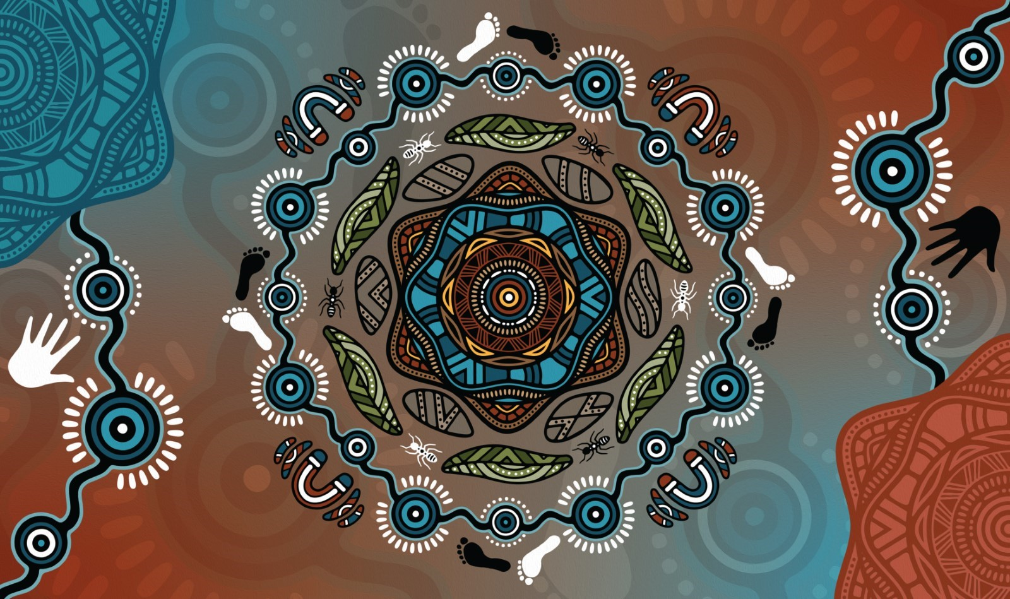
Image: Artwork by Dixon Patten (Bitja)

Message from artist:

Ambulance Victoria has a special place in our society as first responders to emergencies. The organisation is responsible for our wellbeing and safety and provides lifesaving interventions and medical care.

Throughout our lifetime we most likely have or know someone who has needed their services and could attribute their assistance in helping nurture emergency situations. This forms the start of a healing journey for those that have needed their aid.

Historically, there has been friction and contention between First Nations people and systemic institutions due to lack of cultural understanding, racism and thus mistrust in healthcare.

The commitment of Ambulance Victoria in the Reconciliation space is to ensure they are exercising cultural safety and understanding the barriers, challenges and building cultural capacity within their business.

The central motif represents our community and sitting in a yarning circle and engaging in two-way deep listening to gain understanding and to build trust. The extension of this turns into a ripple effect, highlighting the importance of how working together positively influences our environments and society.

The healing stones and gum leaves represent our individual and collective healing journeys.

The ants are symbolic of patience, teamwork, cooperation, and communal strength.

The outer circles depict our diverse communities and their diverse needs; and the pathways represent our connection to each one another. Despite our race, gender, sexual orientation and religion; our needs as people are more common than our differences.

The black and white feet and hands represent First Nations and the broader community working together to ensure cultural understanding, safety and ensuring capacity building is at the forefront of interactions to help heal, build equity and unite our community.

Access to spiritual, emotional and physical wellbeing should be a universal right and our country and community have worked together to ensure there is accessibility to these rights. The reconciliation commitment is another right step in this direction.

The 'U' shape symbols honour the selfless devotion, commitment and generosity of everyone at Ambulance Victoria; from the paramedics, call-takers and operational staff.

Bitja (Dixon Patten)
Yorta Yorta, Gunnai, Gunditjmara, Djab Wurrung, Wemba Wemba, Dhudhuroa, Monero, Waywurru, Wadi Wadi, Monero/Ngarigu

Our Reconciliation Action Plan
AV sees significant improvements in patient care when we partner with Aboriginal and Torres Strait Islander communities.
A Reconciliation Action Plan contributes to reconciliation by:
- Guiding our relationship building between Aboriginal and Torres Strait Islander peoples, communities, organisations, and the broader community
- Helping us continue to learn about and develop opportunities to improve health outcomes for Aboriginal and Torres Strait Islander peoples and communities
- Enriching our understanding and appreciation of, and engagement with one of the world’s oldest continuing living cultures
- Helping us live our values and connect with organisations who seek to be leaders in inclusion and signal our commitment to support the national reconciliation movement
- Supporting our goal of achieving social and environmental responsibility.
Every patient is unique. AV seeks to understand their cultural needs and contexts, recognising this is the best way to achieve positive health outcomes.
To provide Best Care, it is important that patients are safe and encouraged to identify whether they are of Aboriginal and/or Torres Strait Islander descent. We will do this through:
- Provision of culturally and linguistically safe health care
- Early intervention or identification of predisposing illness and monitoring health patterns
- Provision of appropriate referrals and patient support
- Ensuring accurate patient records.

Our journey to the Reconciliation Action Plan
The development of the 2019 Cultural Safety and Equity Action Plan was a catalyst for conversations and deep evaluation of how AV can further engage with Aboriginal and Torres Strait Islander peoples. Through this period, AV developed an organisational Statement of Commitment to highlight AV’s duty to take a sector-leading role to enhance relationships with Aboriginal and Torres Strait Islander peoples that foster better health outcomes and community standing.
To progress our relationships, respect and understanding of the cultural, socio-economic, and healthcare needs of the Aboriginal and Torres Strait Islander communities of Victoria, we committed to developing our first Reconciliation Action Plan. We know this work will ensure AV focuses on cultural safety and reconciliation, enabling us to provide supportive and culturally safe emergency healthcare services within a culturally safe workplace.
Acknowledging the importance of reconciliation and the work needed to progress this, in 2022 AV created an Aboriginal and Torres Strait Islander Program Lead role. This role, within the Diversity and Inclusion Department of the Equality and Workplace Reform Division, provides subject matter expertise to guide AV’s workplan relating to Aboriginal and Torres Strait Islander matters. Developing this RAP has been a key focus of this role.
Within AV, the RAP will also integrate with several organisational strategies and priorities, including the annual Statement of Priorities, Your AV Roadmap 2022-27, the Prevention Plan, and the Community and Consumer Engagement Plan.
The Executive Director of the Equality and Workplace Reform Division will play a critical leadership role at AV as RAP Champion during the implementation of this action plan.

Our Reconciliation Working Group
Our Reconciliation Working Group consists of AV staff from diverse roles and regions and representatives from external Aboriginal and Torres Strait Islander community organisations.
AV recognises and thanks this incredible team for their passion, commitment, wisdom, expertise, and contributions of AV’s Reconciliation Working Group. It is an essential, respected, and valued group of individuals who, together, guide and educate AV in how we can improve our workplace and care. The group has been fundamental in developing our RAP and reconciliation pathways and outcomes.
A list of 2023 Reconciliation Working Group Members:
- Elder Aunty Jacqui Stewart, Taungurung Land and Waters Council, Taungurung
- Simone Cusack, Executive Director Equality & Workplace Reform (Chair)
- Michelle Crilly, Aboriginal and Torres Strait Islander Program Lead and Ambulance Paramedic (Secretariat), Yorta Yorta
- Chloe Anderson, Ambulance Paramedic, Wiradjuri
- Eddie Wright, Regional Support Manager, Gippsland, Gunaikurnai
- Joel Marley, Manager Community & Partner Engagement
- Joel Pearlman, Senior Lead Diversity and Inclusion
- Kenton Winsley, Ambulance Paramedic, Belyuen/Nauiyu
- Lana Wilson, Advisor Employee Communication
- Michael Konstantinou, Ambulance Paramedic
- Ryan Parry, MICA Paramedic, Bunurong
- Steph O'Connor, Graduate Paramedic, Gubbi-Gubbi
- Timothy Fraser, Loddon Mallee Greater Bendigo Senior Team Manager 2

Our partnerships and current activities
AV has a rich history of connecting with Aboriginal and Torres Strait Islander communities and participating in important partnerships and activities.
We are focused on developing and nurturing existing relationships with communities outside of our organisation and improving the skills and capabilities of our people to ensure Best Care for our patients and a culturally safe, fair and inclusive workplace for our staff and volunteers.
Some of the ways we are doing so are outlined below:
- Since 2017, online mandatory cultural awareness training for AV’s workforce has provided foundation-level knowledge in Aboriginal and Torres Strait Islander histories, cultures, and societies. It provides a practical guide for working with Aboriginal and Torres Strait Islander peoples by exploring common myths and misconceptions, and addressing communication, obligations, and respect for cultural protocols. Content is regularly updated and was refreshed November 2021.
- In 2021, we developed and promoted ‘You can ask me that’, a video series featuring Aboriginal and Torres Strait Islander staff and community members talking about reconciliation and what their rich heritage means to them and explaining why it is important to ask patients if they identify as Aboriginal and/or Torres Strait Islander. The series raised awareness across the workforce of cultural safety and sensitivity issues experienced by our patients and workforce.
- We are working with the Victorian Aboriginal Community Controlled Health Organization (VACCHO) and some of its community-controlled partners to deliver life-saving training to Aboriginal and Torres Strait Islander community members. These 'Call Push Shock' sessions promote confidence and capacity to respond to a cardiac arrest in the Barwon Southwest Region. This program has been ongoing since 2018 and available statewide across schools, communities, corporate and the public sector.
- In 2019, as part of the Cultural Safety and Equity Action Plan, we started educating all paramedics and first responders across the state on the importance of asking patients if they identify as an Aboriginal and/or Torres Strait Islander person to better understand and improve patient hospital admission and healthcare outcomes. Training staff and volunteers in the use and collection of patient data supports best practice guidelines and a Best Care experience for our patients.
- In 2019, the Best Care Innovation Fund was created to offer seed funding of up to $10,000 per project for projects that improve the quality, safety and experience of our care and the systems that support us to deliver Best Care. To support cultural safety and equity, regions across the state were able to access the funding for different projects including:
  - Installing a mural at Belmont branch by local artist Billy-Jay O'Toole.
  - Delivering cultural safety awareness training for staff and volunteers across the Gippsland region.
  - Installing 'Acknowledgement of Country' plaques for the Echuca and Kyabram branches (written and designed by a Yorta Yorta Elder).
  - Building a garden and mural at the Shepparton branch by Aboriginal artist Tom Day (see image below).
  - Installing ‘Acknowledgement of Country’ plaques at the Wendouree, Beaufort, Horsham and Dimboola ambulance branches across the Grampians region.
- We are building on relationships with Aboriginal Community Controlled Health Organisations through our Operational Community Engagement and Liaison Coordinators (OCELC). The coordinators assist our workforce in planning community engagement activities, providing key messages and resources. They engage with local health services, local government services and emergency stakeholders in their areas with projects and initiatives that empower them to make better informed health decisions and create better health outcomes. We currently have six OCELCs across the state in each region.

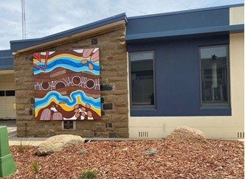

Image: Shepparton ambulance branch with an Aboriginal mural on the side designed by Tom Day.

Our actions
Action 1. Establish and strengthen mutually beneficial relationships with Aboriginal and Torres Strait Islander stakeholders and organisations.
Deliverables:
1.1. Identify Aboriginal and Torres Strait Islander stakeholders and organisations within our local area, state-based partnerships, or sphere of influence. Timeframe, May 2023. Responsibility, Senior Lead Diversity & Inclusion.
1.2. Research best practice and principles that support partnerships with Aboriginal and Torres Strait Islander stakeholders and organisations. Timeframe, April 2024. Responsibility, Senior Lead Diversity & Inclusion.
1.3. Develop internal framework to support partnerships with Aboriginal and Torres Strait Islander stakeholders and organisations. Timeframe, December 2024. Responsibility Senior Lead Diversity & Inclusion.
Action 2. Build relationships through celebrating National Reconciliation Week (NRW).
Deliverables:
2.1. Circulate Reconciliation Australia’s NRW resources and reconciliation materials to our staff. Timeframe, May 2023 & 2024. Responsibility, Senior Manager Employee Communications.
2.2. Reconciliation Working Group members to participate in an external NRW event. Timeframe, 27 May – 3 June 2023 & 2024. Responsibility, Senior Lead Diversity & Inclusion.
2.3. Encourage and support staff and senior leaders to participate in at least one external event to recognise and celebrate NRW. Timeframe, 27 May – 3 June 2023 & 2024. Responsibility, Senior Manager Community & Partner Engagement.
2.4. Support NRW activities with Aboriginal health sector partners across Victoria in each region. Timeframe, May 2023. Responsibility, Senior Manager Community & Partner Engagement.
2.5. Develop an NRW engagement package to support the organisation’s involvement across the state. Timeframe, May 2023. Responsibility, Senior Manager Community & Partner Engagement.
2.6. Encourage Reconciliation Working Group members to participate in internal communication explaining their experience with reconciliation and what it means to them. Timeframe, May 2023. Responsibility, Senior Manager Employee Communications.
Action 3. Promote reconciliation through our sphere of influence.
Deliverables:
3.1. Communicate our commitment to reconciliation to all staff. Timeframe, May 2023 . Responsibility, Senior Manager Employee Communications.
3.2. Identify RAP and other like-minded organisations that we could approach to collaborate with on our reconciliation journey. Timeframe, June 2023. Responsibility, Senior Lead Diversity & Inclusion.
3.3. Maintain a register of stakeholder contacts to monitor and improve the effectiveness of engagement activities. Timeframe, June 2023. Responsibility, Senior Lead Diversity & Inclusion.
3.4. Share experience and learnings from engagement events to improve cultural understanding across AV. Timeframe, June 2023. Responsibility, Senior Manager Community & Partner Engagement.
Action 4. Promote positive race relations through anti-discrimination strategies.
Deliverables:
4.1. Research best practices and policies in areas of race relations and anti-discrimination. Timeframe, March 2024. Responsible, Senior Lead Diversity & Inclusion.
4.2. Conduct a review of HR policies and procedures to identify existing anti-discrimination provisions and future needs. Timeframe, December 2024. Responsible, Senior Lead Diversity & Inclusion.
Action 5. Increase understanding, value and recognition of Aboriginal and Torres Strait Islander cultures, histories, knowledge and rights through cultural learning, to improve the service we provide.
Deliverables:
5.1. Develop a business case for increasing understanding, value and recognition of Aboriginal and Torres Strait Islander cultures, histories, knowledge and rights within our organisation. Timeframe, December 2024. Responsible, Senior Lead Diversity & Inclusion.
5.2. Conduct a review of cultural learning needs within our organisation. Timeframe, December 2024. Responsible, Senior Lead Diversity & Inclusion.
5.3. Distribute online resources to senior managers and support staff featuring podcasts, TED talks and short films exploring cultures, histories, and social issues from First Nations people. Timeframe, June 2023. Responsible, Senior Manager, Community & Partner Engagement.
5.4. Develop a plan to provide support and education on culturally appropriate ways to offer patients the opportunity to self-identify as an Aboriginal and/or Torres Strait Islander person. Timeframe, December 2024. Responsible, Senior Lead Diversity & Inclusion.
5.5. Regularly extract data on AV staff and volunteers asking patients if they identify as Aboriginal and/or Torres Strait Islander and report through RAP governance structure. Timeframe, October 2023. Responsible, Director of Clinical Governance & Programs.
Action 6. Demonstrate respect to Aboriginal and Torres Strait Islander peoples by observing cultural protocols.
Deliverables:
6.1. Develop an understanding of the local Traditional Owners or Custodians of the lands and waters within our organisation’s operational area. Timeframe, October 2023. Responsible, Senior Lead Diversity & Inclusion.
6.2. Increase team member’s understanding of the purpose and significance behind cultural protocols, including Acknowledgement of Country and Welcome to Country protocols. Timeframe, October 2023. Responsible, Senior Lead Diversity & Inclusion.
6.3. Develop a stakeholder map and regional profiles of the Aboriginal communities we engage with, in partnership with the communities involved. Timeframe, October 2023. Responsible, Senior Lead Diversity & Inclusion.
6.4. Encourage AV staff and volunteers to develop their unique Acknowledgements of Country. Timeframe, October 2023. Responsible, Senior Lead Diversity & Inclusion.
Action 7. Build respect for Aboriginal and Torres Strait Islander cultures and histories by celebrating NAIDOC Week.
Deliverables:
7.1. Raise awareness and share information among our team members about the meaning and theme of NAIDOC week. Timeframe, June 2023 & 2024. Responsible, Senior Manager of Employee Communications.
7.2. Introduce our team members to NAIDOC Week by promoting external events in our local area. Timeframe, June 2023 & 2024. Responsible, Senior Manager of Employee Communications.
7.3. Reconciliation Working Group to participate in an external NAIDOC Week event. Timeframe, June 2023 & 2024. Responsible, Senior Manager Community & Partner Engagement.
Action 8. Improve employment outcomes by increasing Aboriginal and Torres Strait Islander recruitment, retention and professional development.
Deliverables:
8.1. Develop a business case for Aboriginal and/or Torres Strait Islander employment within our organisation. Timeframe, December 2024. Responsible, Senior Lead Diversity & Inclusion.
8.2. Build understanding of current Aboriginal and Torres Strait Islander staffing to inform future employment and professional development opportunities. Timeframe, December 2024. Responsible, Senior Lead Diversity & Inclusion.
Action 9. Increase Aboriginal and Torres Strait Islander supplier diversity to support improved economic and social outcomes.
Deliverables:
9.1. Develop a business case for procurement from Aboriginal and Torres Strait Islander owned businesses. Timeframe, May 2023. Responsible, Manager Social Procurement.
9.2. Investigate Supply Nation membership to develop relationships and new opportunities to work with Aboriginal and Torres Strait Islander businesses. Timeframe, May 2023. Responsible, Manager Social Procurement.
9.3. Include non-weighted evaluation criteria for suppliers with Reconciliation Action Plans in relevant procurement processes. Timeframe, May 2023. Responsible, Manager Procurement Governance & Reporting.
Action 10. Establish and maintain an effective Reconciliation Working Group to drive governance of the RAP.
Deliverables:
10.1. Maintain a Reconciliation Working Group to govern RAP implementation. Timeframe, ongoing. Responsible, Senior Lead Diversity & Inclusion.
10.2. Finalise Terms of Reference for the Reconciliation Working Group. Timeframe, May 2023. Responsible, Senior Lead Diversity & Inclusion.
10.3. Maintain Aboriginal and Torres Strait Islander representation on the Reconciliation Working Group. Timeframe, ongoing. Responsible, Senior Lead Diversity & Inclusion.
Action 11. Provide appropriate support for effective implementation of RAP commitments.
Deliverables:
11.1. Maintain resource needs for RAP implementation. Timeframe, ongoing. Responsible, RAP Champion.
11.2. Engage senior leaders in the delivery of RAP commitments. Timeframe, May 2023. Responsible, RAP Champion.
11.3. Appoint a senior leader to champion our RAP internally. Timeframe, May 2023. Responsible, RAP Champion.
11.4. Define appropriate systems and capability to track, measure and report on RAP commitments. Timeframe, May 2023. Responsible, RAP Champion.
Action 12. Build accountability and transparency through reporting RAP achievements, challenges and learnings, both internally and externally.
Deliverables:
12.1. Contact Reconciliation Australia to verify that our primary and secondary contact details are up to date, to ensure we do not miss out on important RAP correspondence. Timeframe, June 2023 & 2024. Responsible, Senior Lead Diversity & Inclusion.
12.2. Contact Reconciliation Australia to request our unique link, to access the online RAP Impact Measurement Questionnaire. Timeframe, 1 August 2023 & 2024. Responsible, Senior Lead Diversity & Inclusion.
12.3. Complete and submit the annual RAP Impact Measurement Questionnaire to Reconciliation Australia. Timeframe, 30 September 2023 & 2024. Responsible, Senior Lead Diversity & Inclusion.
Action 13. Continue our reconciliation journey by developing our next RAP.
Deliverable:
13.1. Register via Reconciliation Australia’s website to begin developing our next RAP. Timeframe, May 2024. Responsible, Senior Lead Diversity & Inclusion.

For more information contact Michelle Crilly, Aboriginal and Torres Strait Islander Program Lead. Equality & Workplace Reform division using email:
michelle.crilly@ambulance.vic.gov.au

