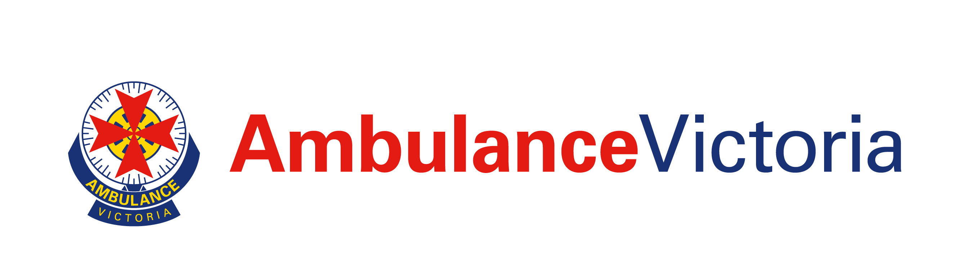Expression of Interest:

Ambulance Victoria

Community Advisory Committee
Over the past four (4) years, Ambulance Victoria (AV) has been undergoing a major transformation to improve the delivery of pre-hospital emergency and medical services to the entire Victorian community.

Our current strategy outlines our bold plan to continue the transformation and deliver on our patient commitment: To deliver outstanding emergency health care every time.

At the heart of everything we do is our Patient Care Commitment, which is our promise to every patient to provide them with a safe, caring, effective and connected experience.

Critical to our ongoing success in fulfilling this commitment is the participation by Victorian community representatives as a part of our Community Advisory Committee (CAC).

The CAC is appointed to ensure the voices of all Victorian communities are heard, understood and integrated across the work and services of AV.

The Committee’s role

- Members are our direct link to Victoria’s communities, and their experience and contributions are highly valued by the AV Board and organisation.

- Members advise (but cannot direct) the Board and management on issues directly impacting the community, to ensure all Victorians have equitable access to safe, effective and timely care – regardless of where they live or who they are.

- Members provide guidance on community needs and impacts when AV develops or changes its policies or services, and how we can improve our community planning and engagement.
- The Committee participates in AV’s strategic planning for the future, and annually reports to the Board on how well we have delivered against our Consumer and Community Engagement Plan.

Your opportunity to contribute:

We are now seeking expressions of interest from members of the community to fill five (5) vacancies on our CAC. The Committee seeks to represent the diversity of the Victorian community.

Expressions of Interest are encouraged from people who reside in regional locations, are from Aboriginal and Torres Strait Islander backgrounds, and who are newly arrived migrants or refugees.

- The Committee is appointed by the AV Board and is subject to the conditions and rules of the attached Terms of Reference.

- Members must be entirely independent of AV and must be able to represent and reflect the views of their community.

- Member contributions and attendance records are reviewed annually by the Committee Chair.

- All appointments remain strictly at the discretion of the Board and may be amended at any time.

- Independent members will be appointed for a term of up to two (2) years or for a term at the discretion of the Board. Members may be reappointed for a further term/s if approved by the Board (at its discretion).

Your role:

As a Community Advisory Committee representative, you will need to:

- Represent and voice the needs of your community members:

  - Are you able to address and communicate issues from a community perspective?
  - Do you have an understanding of health issues generally?
  - Do you have a knowledge of, and interest in, local community health and related issues?
  - Are you able to reach out and connect with minority groups?
  - Do you have an established broad network of organisations within your area you can consult?
  - Have you undertaken, or are you willing to undertake training relevant to this appointment (paid for by AV)?

- Communicate effectively:

  - Do you have good communication skills?
  - Are you prepared to report back to your local community with written and/or spoken communication?
  - Do you have an understanding of and commitment to observe confidentiality and privacy when it is required?
  - Are you able to communicate via email and participate in video conference meetings?

- Work collaboratively with others:

- Are you able to work effectively in a team environment?
- Do you have, and can demonstrate, respect for fellow committee members and staff from a variety of backgrounds and viewpoints?
- Are you able to work effectively on a committee or are you willing to develop these skills with appropriate training and support?

Meeting commitment required

The Committee meets five (5) times a year in accordance with its Work Plan. This is inclusive of an annual joint meeting with the AV Board Quality and Safety Committee.

Committee members are expected to attend a minimum of 75% of meetings.

The meetings are usually held at the Doncaster Boardroom but are presently held via video conference due to COVID-19 restrictions. Upon agreement, meetings may also be conducted in regional locations.

Members are paid for their attendance at meetings (up to $216 per day inclusive of pre-reading and meeting preparation) and will be reimbursed for reasonable travel expenses in accordance with AV’s policies.

The full terms of reference for the Committee (as they stand at this time) are attached.

Membership

The Committee’s membership includes two (2) AV Board Directors and is currently chaired by AV Board Director Colleen Furlanetto OAM. It also includes up to a maximum of nine (9) independent Community members. Other attendees at meetings include the AV CEO and various Executive Directors.

Selection

The successful applicant will be selected via the following process:

- Submission of an AV CAC Expression of Interest form, detailing interest and relevant experience (with a copy of current CV)
- Shortlisting by the Evaluation Panel
- Interviews held by the Evaluation Panel
- Reference checks by AV
- Endorsement by the Chair of the Community Advisory Committee
- Approval by the Board of Directors.

The Committee requires applicants to be fully committed to the opportunity, and to therefore:

- Be available and committed to attend meetings
- Have requisite time to read the Committee’s papers
- Strictly observe the confidentiality provisions associated with the appointment
- Be comfortable to contribute to Committee discussions.

Members are appointed as individuals rather than representatives of organisations. Individuals employed by or representing a health service organisation are not eligible for appointment.

Application Process

Applications are to be submitted to Caralene Moloney, Senior Manager, Community and Partner Engagement at caralene.moloney@ambulance.vic.gov.au by close of 24th February 2023.

